# Lab 2

## Establish Connectivity between End Devices

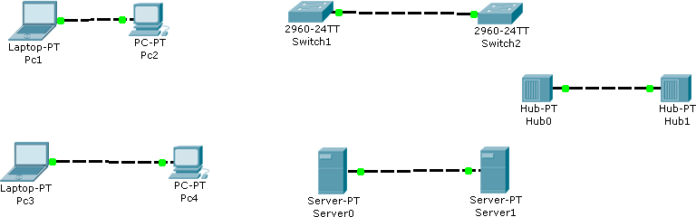

1. Drag & Drop All the END devices & Intermediary devices
2. Connect these Devices with Copper Cross over cable
3. After establishing the connectivity between all the devices check that all devices must be Showing GREEN signal

## Establish Connectivity A Client & Switch

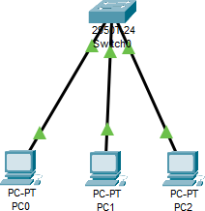

1. Drag & Drop All the END devices & Network device (switch)
2. Connect these Devices with Straight through cable
3. After establishing the connectivity between all the devices check that all devices must be Showing GREEN signal

## Establish Connectivity Between End Devices & Switch & Router

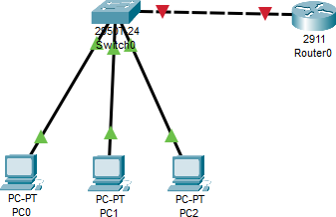

1. Drag & Drop All the END devices & Network device (switch & router)
2. Connect these End Devices with Switch using Straight through cable
3. Connect the Switch with Router using Copper Crossover cable
4. After establishing the connectivity between all the devices check that all devices must be Showing GREEN signal (except router to switch)
5. Click on router and go to config and open the port which is in use (GigabitEthernet0/0 or 0/1 or 0/2)

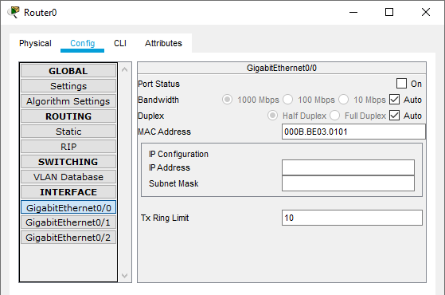

1. Click on the “Port Status” and turn it on.
2. 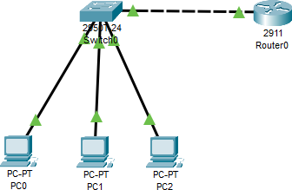After turning it on the connectivity between all the devices must be Showing GREEN signal

**Task 1;**

# Lab 2 - Task

**Why are we using 2911 router and not the others?**

The **Cisco 2911** router is part of the **ISR (Integrated Services Router) G2** series, which makes it a solid choice for many lab and practical networking setups. Here’s why it might be chosen over other routers:

1. **Versatile and Modular:**
   * The Cisco 2911 router is modular, meaning it allows for various **WAN interfaces, security modules, and voice modules**. This versatility makes it ideal for a wide range of network setups, especially if you need to experiment with different network technologies.
2. **Integrated Services:**
   * It supports a variety of services, including **VPNs, security features (like firewalls and intrusion prevention)**, and **WAN optimization**, making it an excellent choice for small to medium-sized enterprise networks.
3. **Affordable for Labs:**
   * While other routers like the 4331 offer more advanced capabilities, the 2911 is **more affordable** and provides sufficient features for typical lab environments or medium-sized networks. You get **good performance without the cost overhead** of high-end models.
4. **Layer 3 Routing Capabilities:**
   * Unlike smaller routers or legacy models, the 2911 has **robust Layer 3 routing features**, allowing it to handle **inter-VLAN routing**, static routes, and dynamic routing protocols (like OSPF, EIGRP, etc.), making it suitable for lab work focusing on routing.

**Task 2;**

Why are we using 2950T or 2960 switch and not the others?

The **Cisco 2950T** and **Cisco 2960** switches are commonly used in labs due to their simplicity, reliability, and cost-effectiveness. Here’s why they are often chosen over other switches:

1. **Layer 2 Switching:**
   * Both the **2950T** and **2960** are **Layer 2 switches**, which means they handle MAC address learning and VLANs but don’t do Layer 3 (routing). This makes them ideal for **basic network switching** tasks, such as creating **VLANs** or simple LAN configurations.
2. **Cost-Effective for Lab Work:**
   * These models are **affordable** and widely available, making them perfect for lab environments where you don’t need advanced features like **Layer 3 routing** or **PoE**. They provide the necessary functionality without unnecessary complexity.
3. **VLAN Support:**
   * Both switches support **VLAN configuration**, allowing segmentation of the network into different logical groups, which is crucial for practicing and learning VLAN concepts in a lab setup.
4. **Uplink Ports (2950T):**
   * The **2950T** model includes **extra uplink ports**, which allow faster connections to other switches or routers. This can be useful in a **multi-switch network** where you need to connect switches together.
5. **More Modern and Widely Used (2960):**
   * The **2960** switch is a more modern Layer 2 switch compared to the 2950T. It is widely used in modern networks, and learning how to configure it provides relevant skills for real-world network environments.
6. **Simple for Small Networks:**
   * These switches are perfect for **small to medium networks** or lab environments where you just need to practice basic **switching, VLAN configuration, and trunking**. Using a more complex switch like the 3560 could add unnecessary complexity if routing between VLANs isn’t required.

## Task 3;

Design the network of "Lab-7" or “Lab-8” (2-3 rows of computers) Use: Switch, Router, & End-Devices like Laptop/PC

